Html:

1. How to have two background styles with two pages when use Vue router.

Google answer:

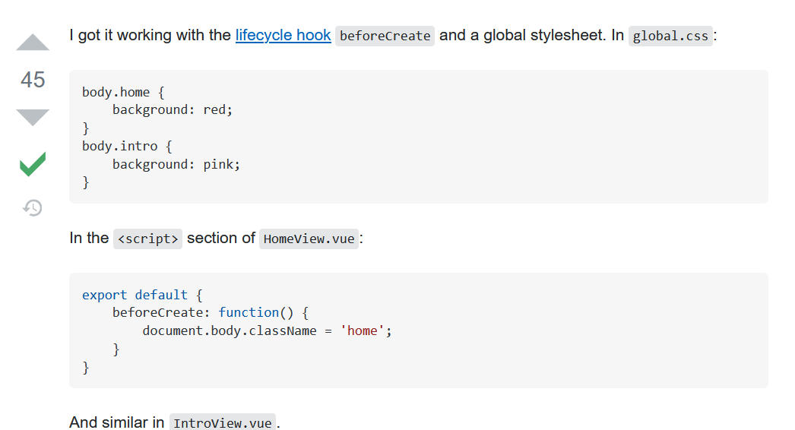

**How I fixed V1:**

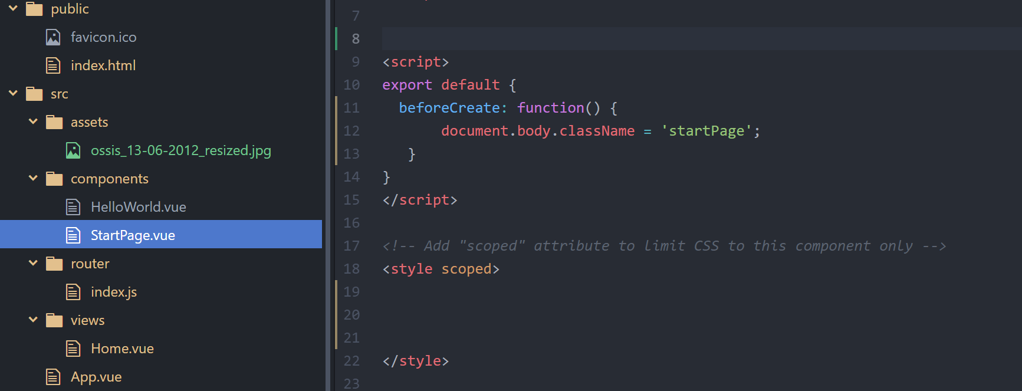

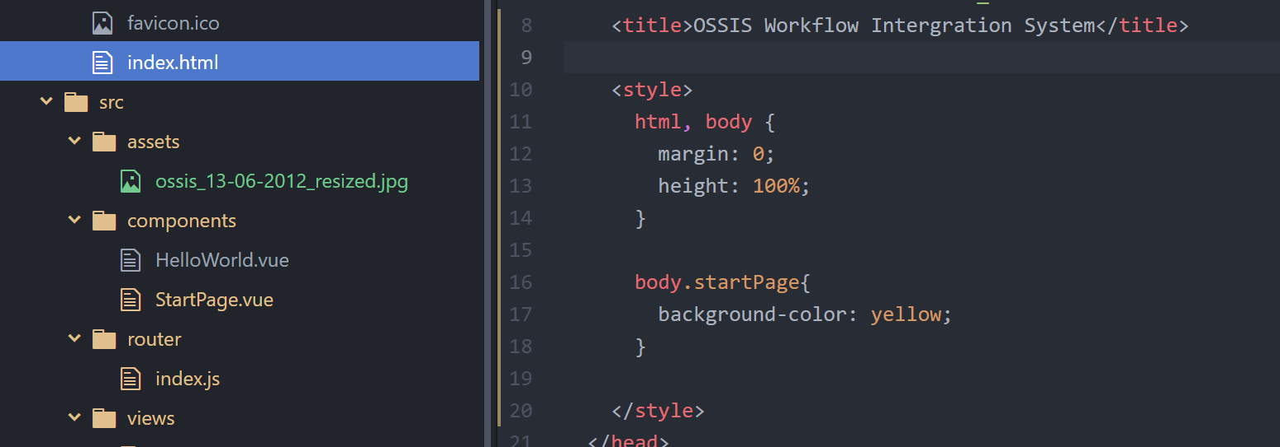

Then I found another way to fix this problem.

Index.html:

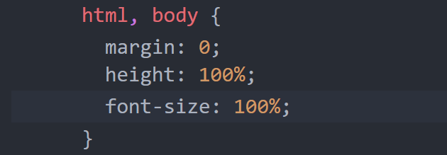

App.vue:

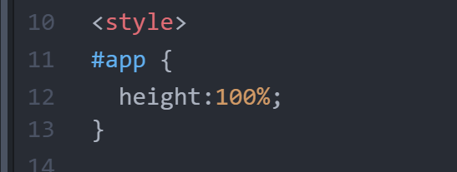

View – home.vue:

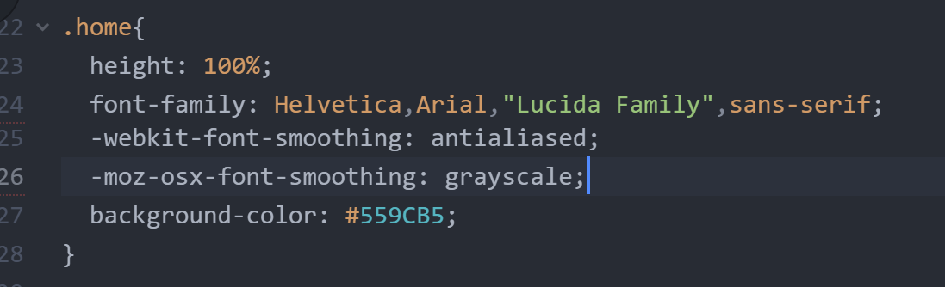

Components – StartPage.vue:

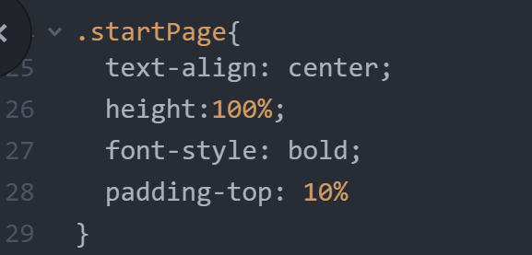

This week I started creating features related to Monday.com

Questions:

1. Data translate between different components;

Currently I use global variable:

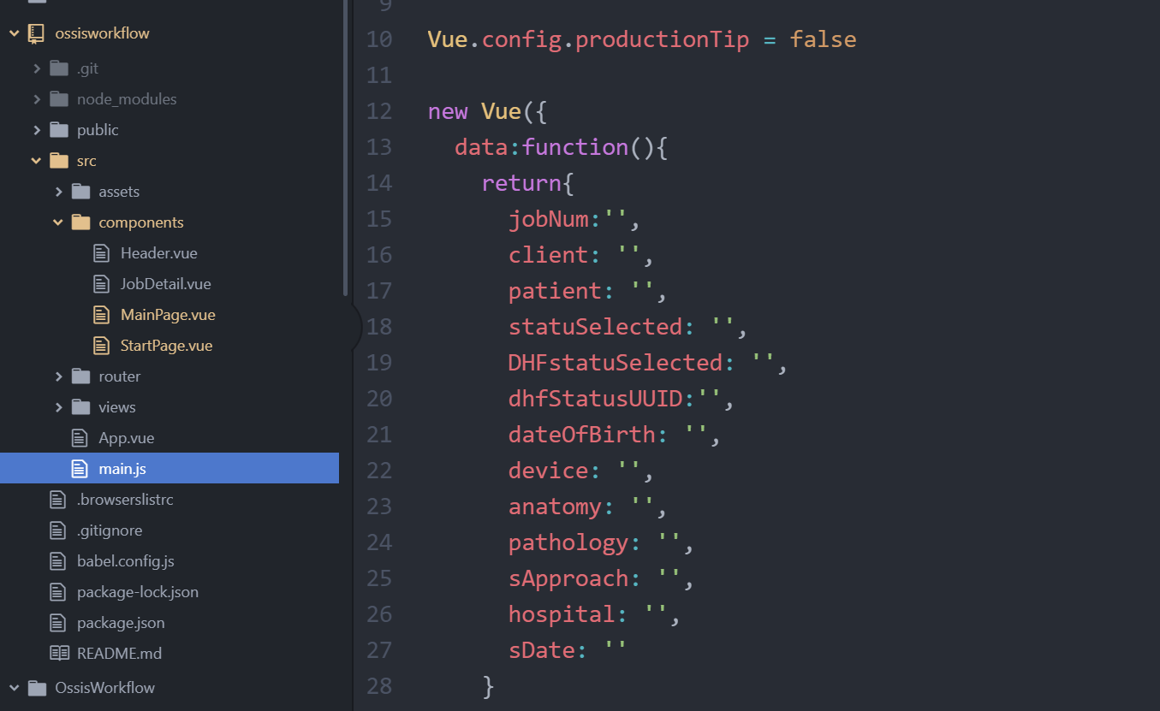

This method needs to be optimized.

1. How to send request to Monday.com
2. When created the ‘creatItemToMonday’ function, how to send the job detail data become a problem.

When I did the test, the format is like this:

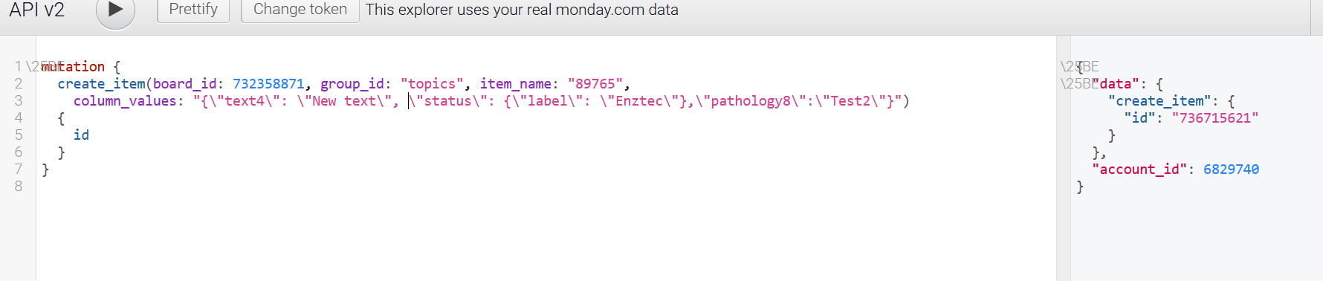

When I write the code, I need to try the way fit for JS:

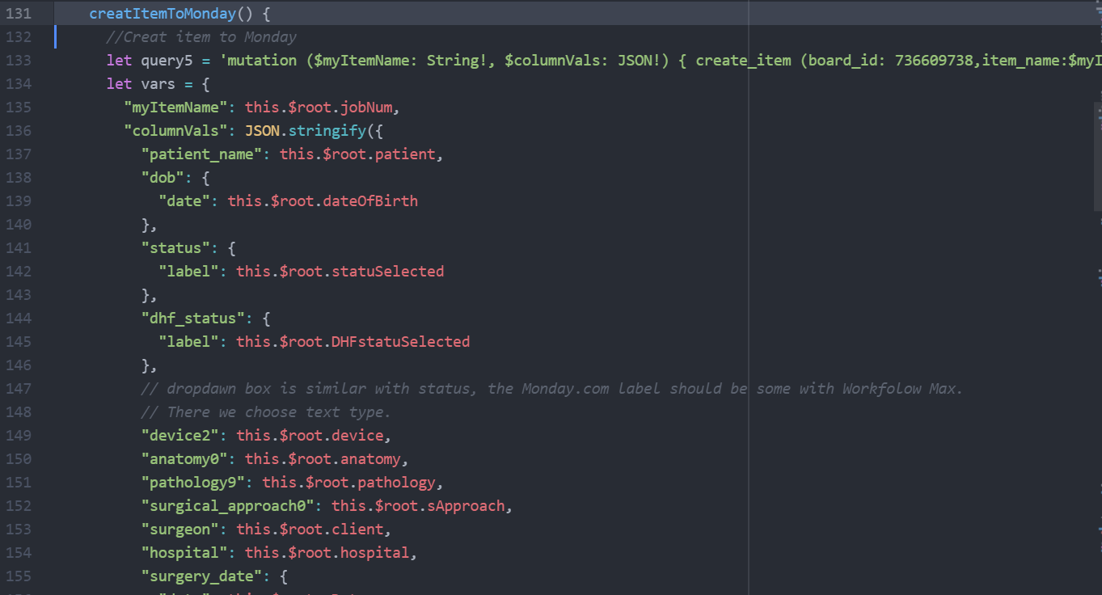

1. During the coding progress, I found that Sync button and update button can be combine to one button. When we click the button, the app needs to judge whether the job is already exit in Monday.com. So, the app can decide whether to create a now job on Monay.com or update the data on Monday.com.

How to judge whether a job is already existed in Monday.com???

First, I send a request to search the Item (Job name), it will return me a list of active items array. Check the length of the array, if the length==0 means the job is not exist.

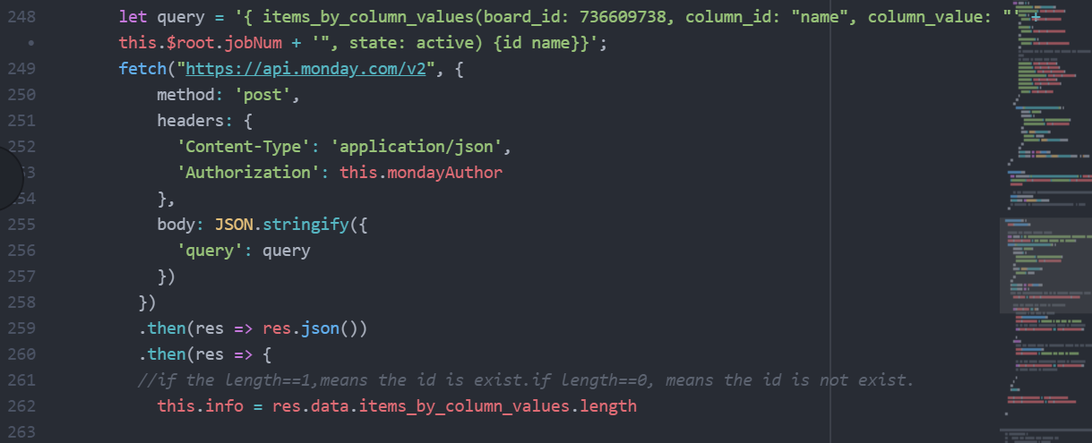

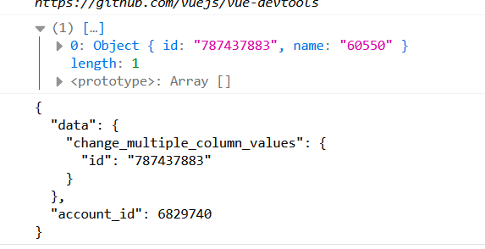

1. Problems caused by asynchronous processing --- need to be optimize
2. Responsive page fonts (px, em, rem, %, vw, vh)

Reference: <https://docs.elementor.com/article/595-difference-between-px-em-rem-percentage-vw-vh>

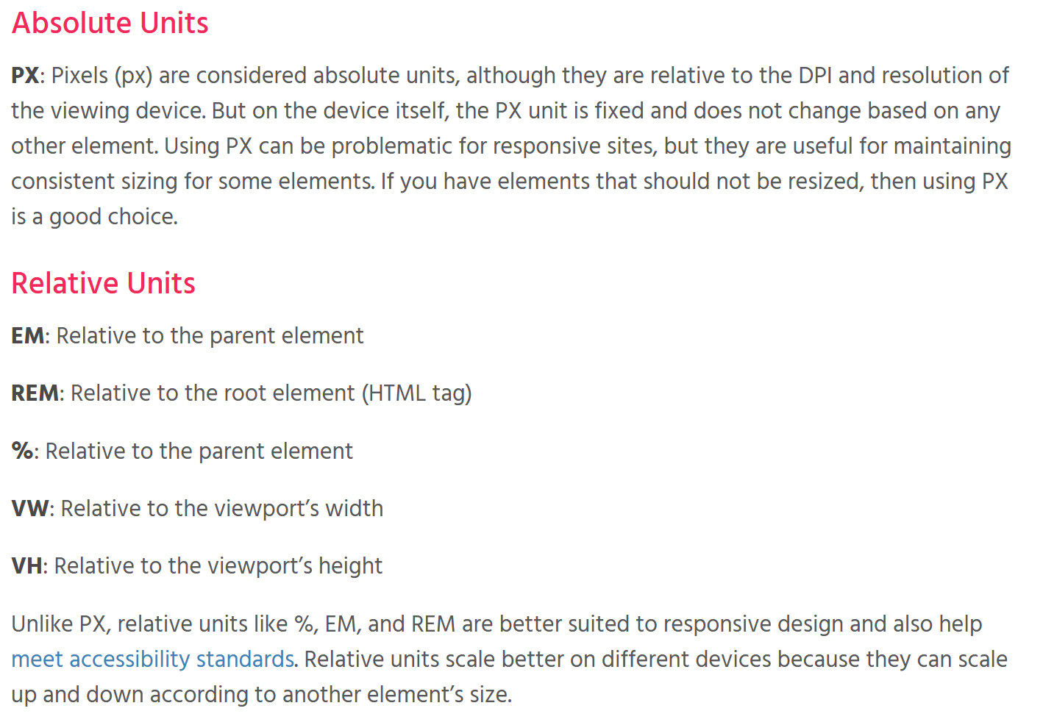

Questions to industry:

Status:

DHF Status:

# VUE –Axios:

**What is Axios:**

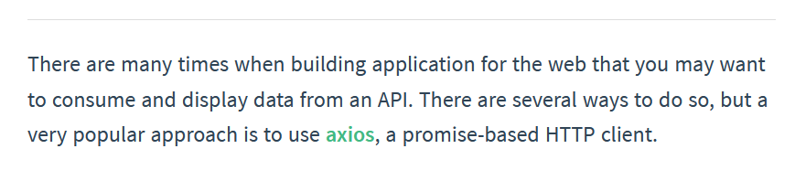

**How to install and test how it work:**

1. Install:



1. Main.js is introduced globally for use by all components:

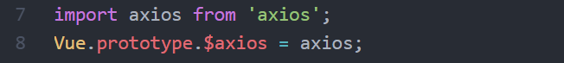

1. Use in components:

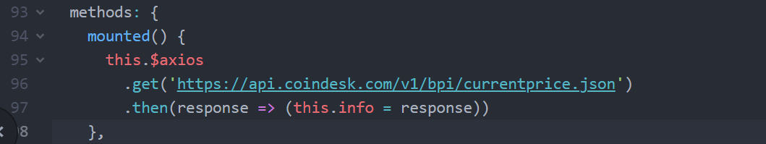



Result:

